Wednesday 8th July 2020
L.O. To design a story character.
A dragon.
In the story ‘Sunflower Sword’ the little knight met a friendly dragon.
Today, create your own dragon for a story.
Are they friendly?
What do they look like?
What games do they like to play?
Where would you go on a dragon ride with them?
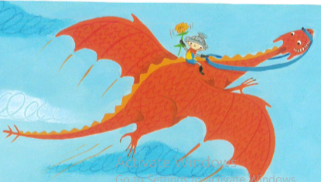

Draw and label your ideas in your home learning book.
Use a range of adjectives and start to think about where you would go, if you went for a ride on a dragon? This will help you on Thursday and Friday.

