Wednesday 1sy July 2020
L.O. To plan a new version of a story.
We’re going on a lion hunt.
In the story ‘We’re going on a lion hunt’ the two main characters visit different places and see different animals on a journey. The language used keeps on repeating. Today, think of some more places the main characters’ visit. What animals might they see? On Thursday and Friday, you are going to write your own version of the story. Today, you are going to plan that story.
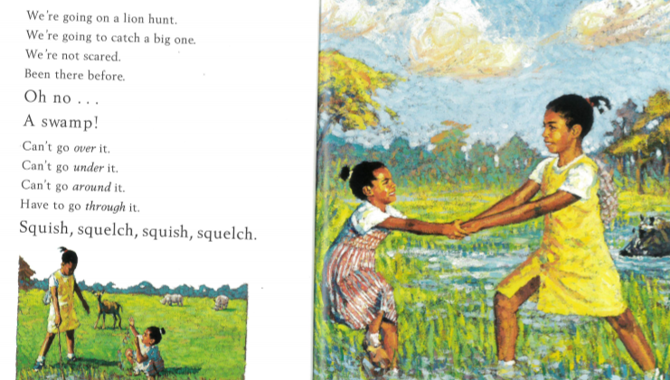

Draw and label your ideas in your home learning book.
What sounds would be made going through the places you visit?
Put your ideas in order.

