Wednesday 17th June 2020
L.O. To write a bird fact file.
Barn Owl/ Kingfisher
Remember-when writing a fact file you will need to use statements.
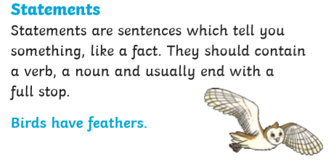
Have a look at the fact cards attached for today. You can use the facts to write statements.

Today, your task is to use the facts about barn owls or kingfishers to write a fact file. You can use one of the sheets given or write straight into your home learning book using the same headings.

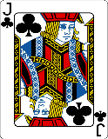  This Photo by Unknown Author is licensed under CC BY-SA | Can you include a range of adjectives/ describing words?  Can you use a range of conjunctions? and, with, that, which

