Wednesday 13th May 2020
L.O. To write a set of instructions.
How to…
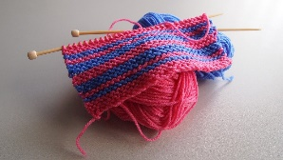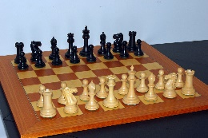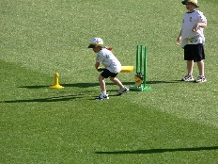

Today, write a set of instructions, for an activity or game of your choice.
You can choose a game or activity that you enjoy, a new skill or game you have learned over the past few weeks.
You can write the instructions in your home learning book and please send them via Seesaw for me to look at.

Remember:
- A title
- Command sentences ( they tell you what to do)
- Sentence openers- First, second, now, next
- Full stops and capital letters
- Number your commands 1, 2, 3 etc

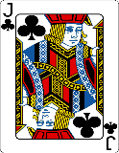  This Photo by Unknown Author is licensed under CC BY-SA | Include diagrams or pictures.

