Wednesday 22nd April 2020
L.O. To use similes
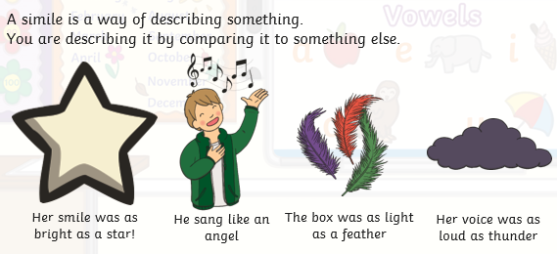

A simile uses the words "as" or "like" make compare two things.
Clouds are like fluffy pillows.
Yellow chicks are like balls of fluff.

Complete these sentences below using similes.
The useful words in the box will help you.
fox thunder dolphin rocket sun fairies house mouse fish laughing tree

1. The boy ran quickly like a __________.
2. The coins shone as brightly as ________________.
3. Jessie swam as smoothly as a ___________________.
4. The giant laughed as loud as _________ ______.
5. The bells tinkled like_______________________.
6. The man was as tall as a_______________.
7. The baby was as quiet as a______________.
8. The boy on the skateboard whizzed by like a ___________________.
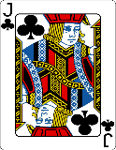  This Photo by Unknown Author is licensed under CC BY-SA | Can you write your own simile for one of the signs of spring ?

