Friday 3rd July 2020
L.O. To write a different version of a familiar story.
We’re going on a lion hunt.
Today, you are going to finish your own story about a journey to find an animal.
Year 1- Describe the places you go on your journey to find an animal.
Year 2- Write your own version of the story, remember to use the same format of the story, like in the page below.
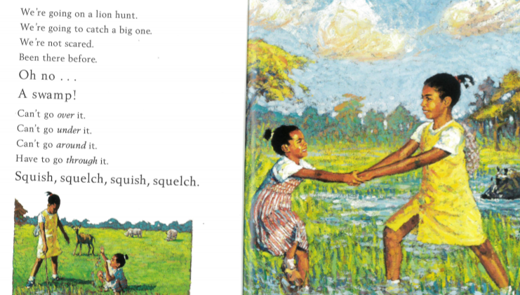

Finish your story.
Read through and check for …
- spelling mistakes
- full stops and capital letters
- clear ending.

Use green pen to edit your work, just like you would at school.
I can’t wait to see your work via Seesaw.

