Friday 19th June 2020
L.O. To write a fact file.
British Birds
Remember-when writing a fact file you will need to use statements.
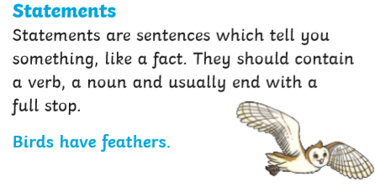
Use your notes from yesterday to write a fact file about the bird of your choice.
You can use one of the sheets given or write straight into your home learning book using the same headings.
You can send me a picture of your work vis Seesaw.

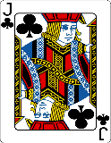  This Photo by Unknown Author is licensed under CC BY-SA | Can you include a range of adjectives/ describing words?  Can you use a range of conjunctions? and, with, that, which

