Friday 24thApril 2020
L.O. To write a descriptive poem.
Spring
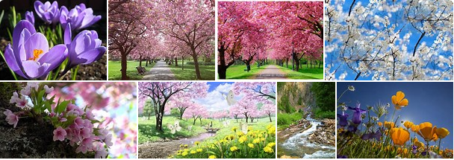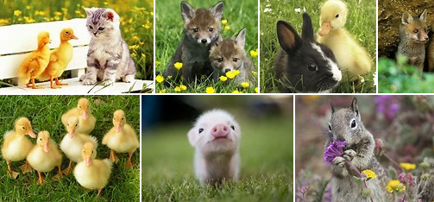
This week we have been using similes, learning poems and looking out for signs of Spring. To finish off this week we will put all that learning together to write a descriptive poem about Spring.

Remember
- Use similes
- Use varied adjectives
- Write a new phrase on a new line
- Think about how all the poems you have read this week have been set out.
- How will you set yours out?

Write your spring poem in your home learning book and decorate.
If your parents email a photo of your poem, then I can put it on the class web page.

