Thursday 9th July 2020
L.O. To plan a story.
A flight with a dragon
In the story ‘Sunflower Sword’ the little knight met a friendly dragon.
Plan your own story about a flight on the dragon you designed yesterday.
Where would you go on a dragon ride? What would you see?
What would you feel?
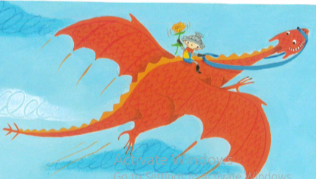

Create a story map in your home learning book.

