Thursday 2nd July 2020
L.O. To write a different version of a familiar story.
We’re going on a lion hunt.
In the story ‘We’re going on a lion hunt’ the two main characters visit different places and see different animals on a journey. The language used, keeps on repeating. Today, you are going to use your story plan to start to write your own version of the story.

Year 1- Describe the places you go on your journey to find an animal.
Year 2- Write your own version of the story, remember to use the same format of the story, like in the page below.
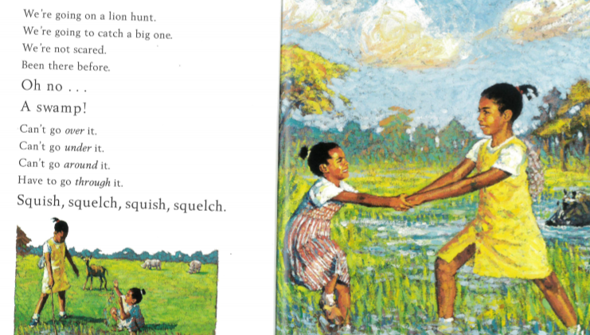

Remember, you are only writing half the story today!
You will finish it tomorrow.

