Thursday 23rd April 2020
L.O. To use similes to describe signs of Spring
Spring
Remember 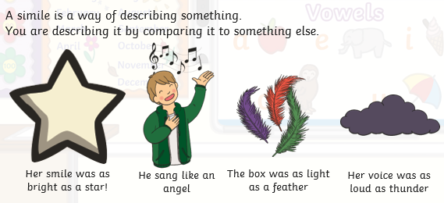
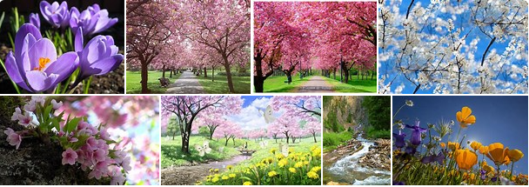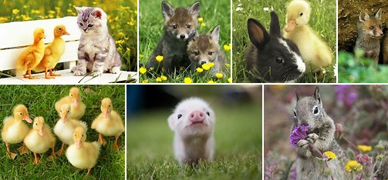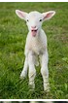
A simile uses the words "as" or "like" make compare two things.
Today write a list of similes to describe the signs of spring.
Try to write about at least 8 signs of spring in your home learning book.
Use the pictures above to help you.

Clouds are like fluffy pillows.
Yellow chicks are like balls of fluff.

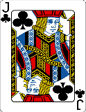  This Photo by Unknown Author is licensed under CC BY-SA | Can you use a range of adverbs and adjectives too?

