Monday 18th May 2020
L.O. To create a story map.
Moschops/ Dinosaur Rumpus.
When writing or telling a story we need to check it has a clear beginning, middle and end. A story map can help you to do this and you can put the events in order.
Today, your task is to create a story map for either the story from guided reading this morning or the video of Moschops you watched last week.
Draw brief pictures for each key bit of the story and add the key vocabulary you need.
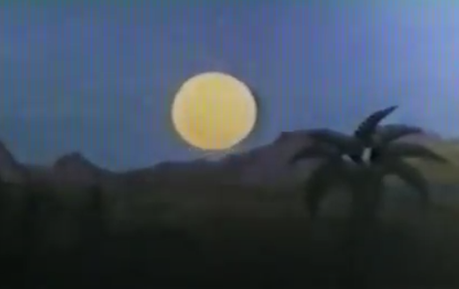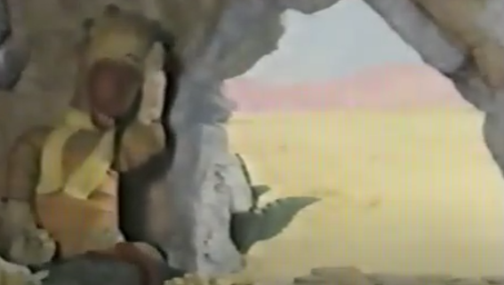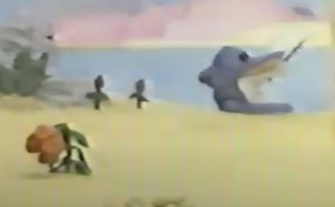
Sun rise Ali Moschops flower singing
Wake up hungry

Draw your story map in your home learning book.

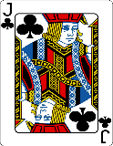  This Photo by Unknown Author is licensed under CC BY-SA | Can you find exciting adjectives in a thesaurus to add to your story map?

