Tuesday 30th June 2020
L.O. To describe an animal.
We’re going on a lion hunt.
In the story ‘We’re going on a lion hunt’ the two main characters visit different places and see different animals on a journey. The language used keeps on repeating. Today think of another animal which you might like to go and look for!
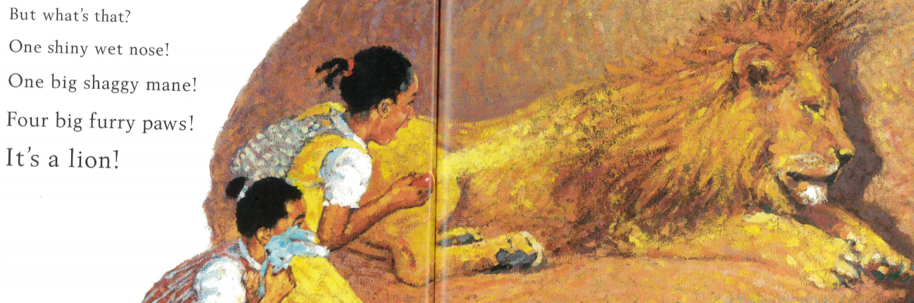

Draw your ideas and write your sentences in your home learning book.
Write about the animal you have chosen to look for.
What does the animal look like? What features does it have?

