Tuesday 23rd June 2020
L.O. To describe a character from a story.
The Gruffalo
Today, your task is to write sentences with adjectives, about the Gruffalo, in your home learning book and then send them via Seesaw to show off your amazing work.
What do they look like?
Are they friendly?
Are they brave?
What do they like or dislike doing?
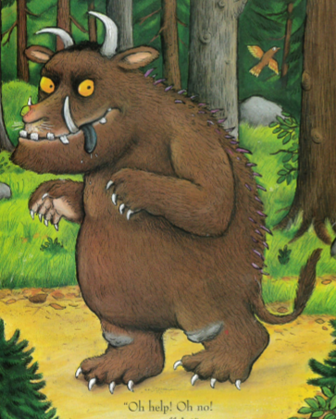
Remember:
- to use a range of conjunctions-and, but, because, that, which, if, so
- capital letters for proper nouns
- exciting adjectives
- commas in lists
- check keyword spellings
- try to form your letters correctly and sit them on the line- Mrs Griffiths is still handing out pen licences!

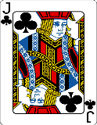  This Photo by Unknown Author is licensed under CC BY-SA | Can you include an exclamation sentence?  Use a thesaurus to find new adjectives words.

