Tuesday 16th June 2020
L.O. To write statements.
Statements about Diurnal Animals
When writing a fact file you will need to use statements.
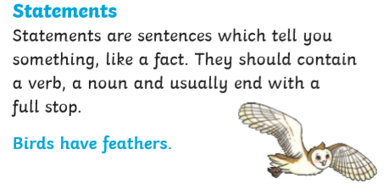
Have a look at the picture below from the last page of the book you read yesterday.
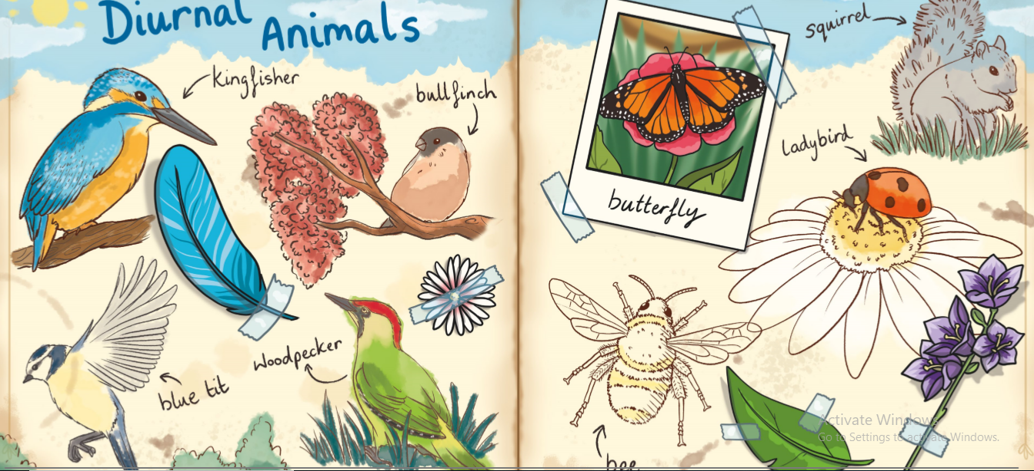
Today, your task is to write statements about the living creatures in the pictures. Remember full stops and capital letters.
For example;
Kingfishers have bright blue feathers on their wings and an orange chest.
Tiny ladybirds can be found on many plants and flowers in your garden.
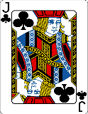  This Photo by Unknown Author is licensed under CC BY-SA | Can you include a range of adjectives/ describing words?  Can you use a range of conjunctions? and, with, that, which

