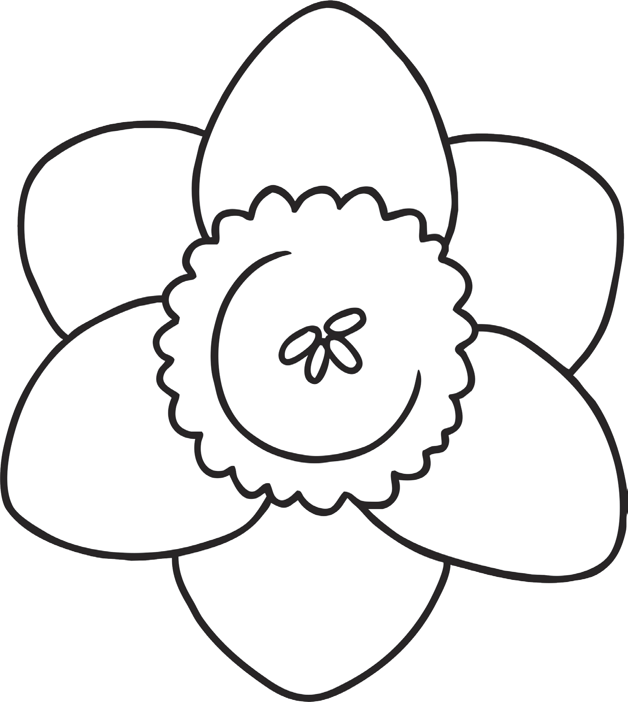
Create a mind map of adjectives and phrases to help you to create a shape poem. Remember to start a new line when you get to the edge of the picture. Can you use alliteration? Can you include a simile?

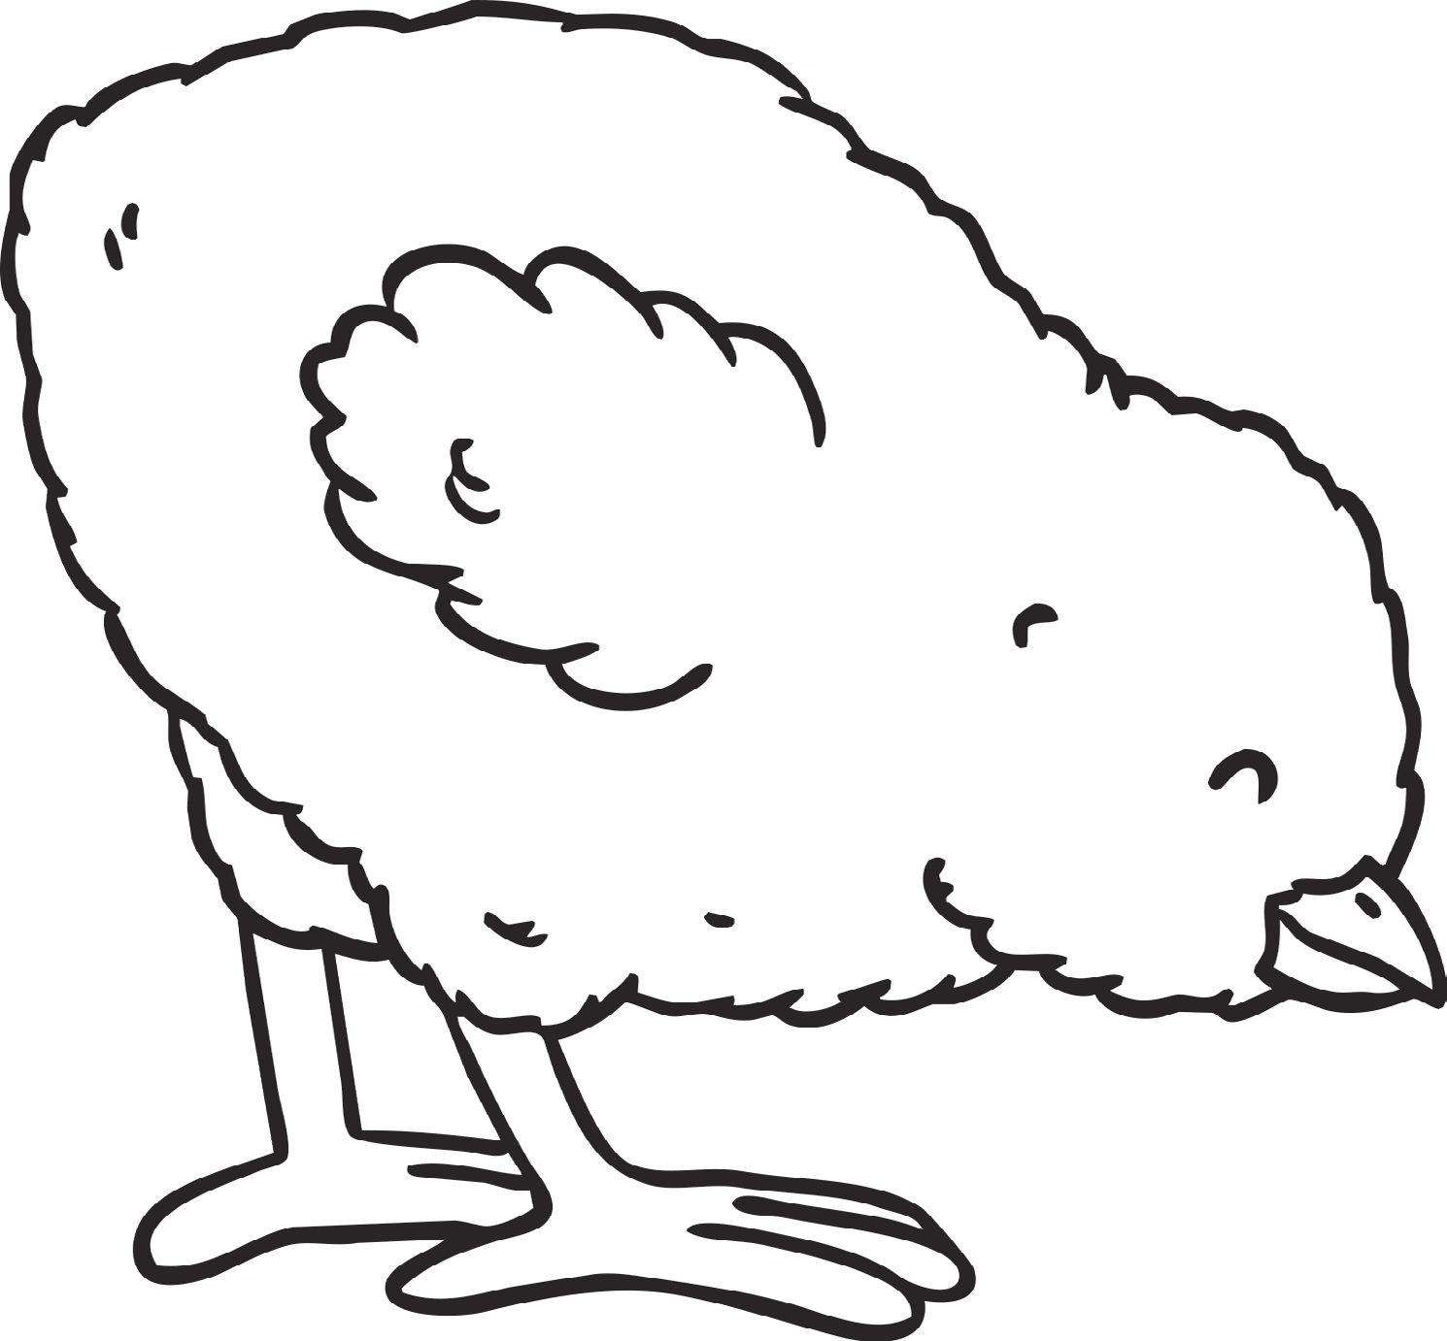
Create a mind map of adjectives and phrases to help you to create a shape poem. Remember to start a new line when you get to the edge of the picture. Can you use alliteration? Can you include a simile?

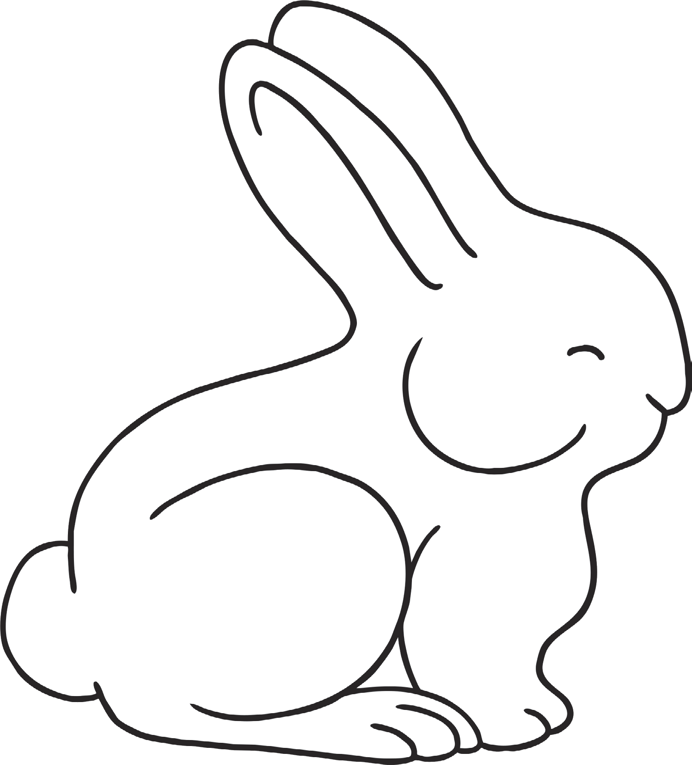
Create a mind map of adjectives and phrases to help you to create a shape poem. Remember to start a new line when you get to the edge of the picture. Can you use alliteration? Can you include a simile?

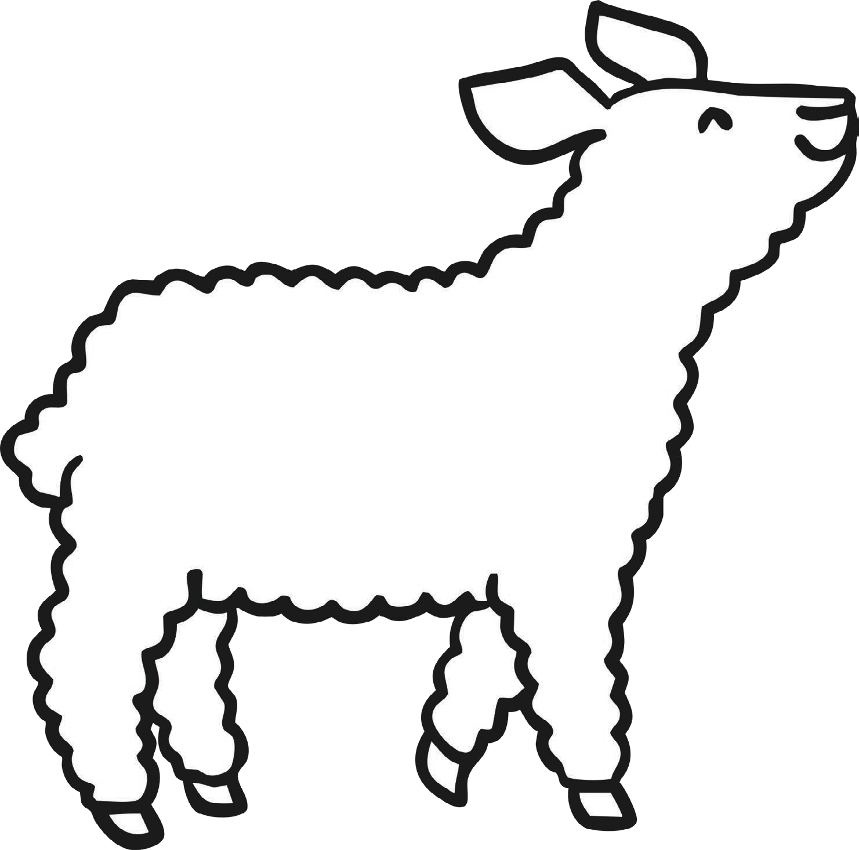
Create a mind map of adjectives and phrases to help you to create a shape poem. Remember to start a new line when you get to the edge of the picture. Can you use alliteration? Can you include a simile?

