ELG Numbers: Children count reliably with numbers from 1 to 20, place them in order and say which number is one more or one less than a given number. Using quantities and objects, they add and subtract two single-digit numbers and count on or back to find the answer. They solve problems, including doubling, halving and sharing.
This week’s focus will be all around doubling and halving.
Starter: count to 100. We enjoy using the video count to 100 everyday Jack Hartman on YouTube.
Main Activity: working through the sheet labelled doubling through Numicon. This is to reinforce any of the parts of the last two days.
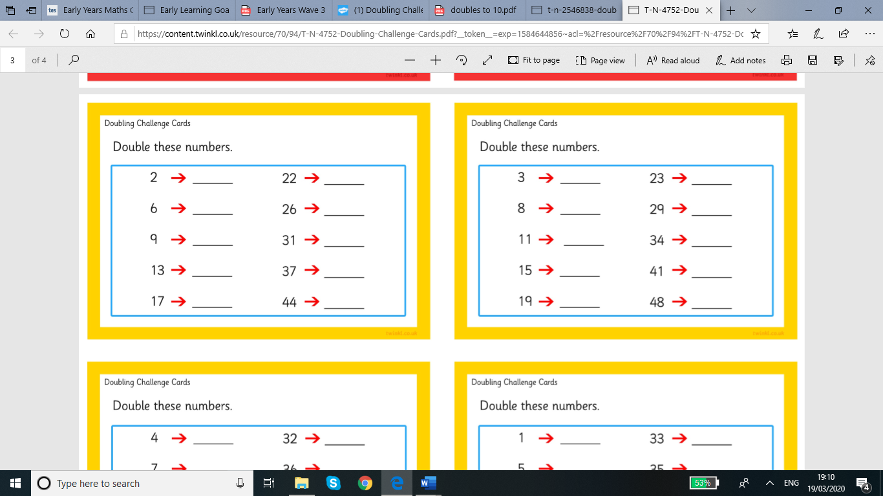
Challenge: These are attached and are a few selected questions that can challenge your child. If they need extra help use objects to help them.
Pictures of work on tapestry would be great but if you are able to print and put in home work books that would be great to.


