Thursday 2nd April 2020
LO: I can write an explanation text for my invention
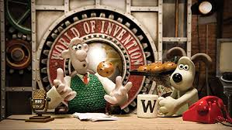
I hope that you had fun letting your imagination go wild!
Today, I would like you to write an explanation text about how your machine works. What are the key functions? How do you make it work?
As with all explanation texts, I would like to see:
- A clear title,
- An opening statement to introduce the process,
- Clear steps to show how your machine works,
- Sub-headings,
- Chronological order and conjunctions.

Have Fun!

