Thursday 26th March 2020
LO: I can use descriptive writing

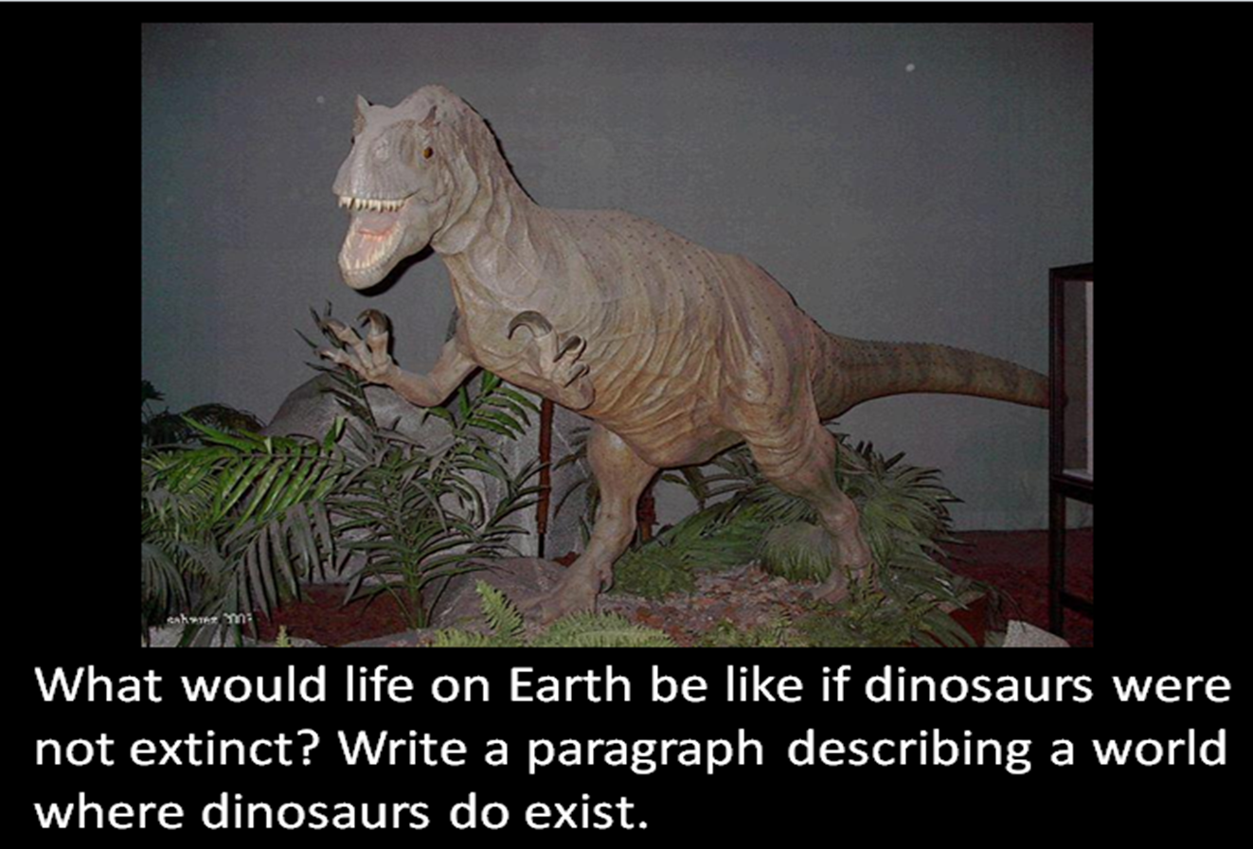

Following these instructions, write your own paragraph that clearly explains what you think life would be like if dinosaurs were still around today.
Think carefully about your choice of adjectives and use a thesaurus to see if you can find any other alternatives.
I would like to be able to close my eyes and picture very clearly, the image that you have in your head.

