Friday 27th March 2020
LO: I can write a diary entry

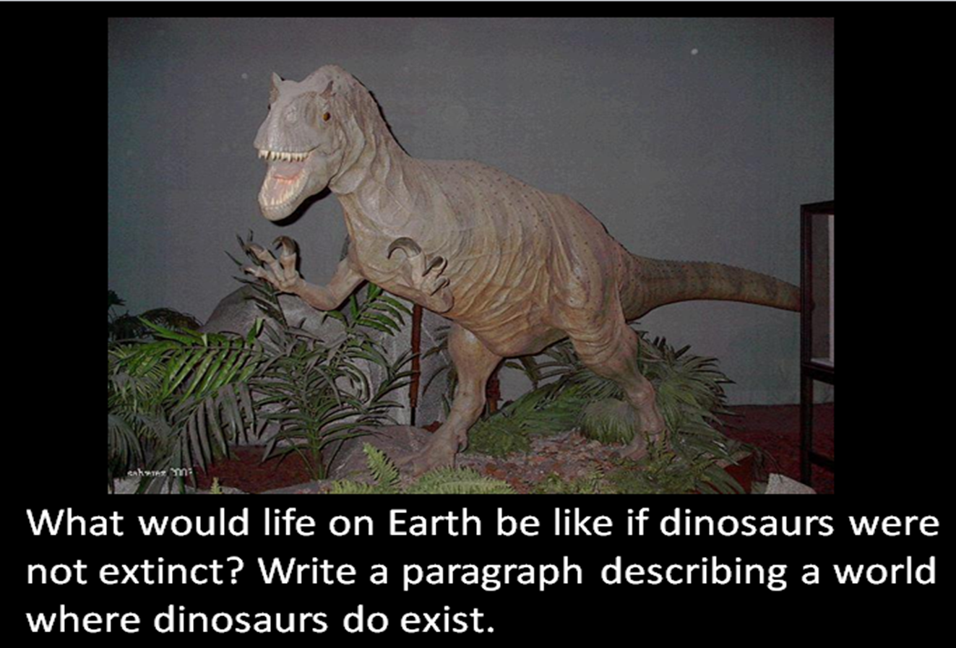

Yesterday, you worked hard to create a descriptive paragraph about what life would be like if dinosaurs were still around today.
Today, you will be using this work to write a diary entry. Tell me about an incident that may have happened between you and a dinosaur…
Use these success criteria to check your work:
- Write in chronological order,
- Write in the first person,
- Include an introduction to set the scene (use your writing from yesterday to help you),
- Include emotions and feelings,
- And use time conjunctions and adverbials.

