Wednesday 1st April 2020
LO: I can design an April fools’ machine
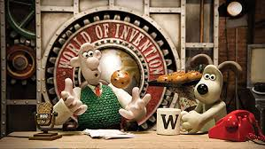
You are tasked with drawing and labelling and April Fools’ machine!
Watch these clips to see the different creations that Wallace and Gromit have come up and with and see what ideas you get.
https://www.youtube.com/watch?v=2igRcGxlshA
https://www.youtube.com/watch?v=d54yH2sNpw4
Your creation must play some form of prank! Please make sure that it wouldn’t cause anybody harm or upset. Other than that, let your imagination go wild!
What name might you give it?

