Wednesday 25th March 2020
LO: I can use questions marks
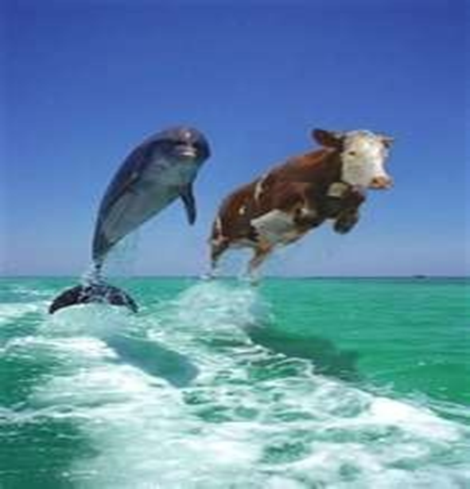

Using this picture, write down 5 questions. Try to make them as imaginative as possible and make sure that they are open ended questions.
Remember – they are not questions without a question mark.

After you have done this, you should pretend that you are either the dolphin or the cow. Answer your questions, using full sentences and appropriate punctuation.

